Welcome Week 2025 Event Plan
Event title: Welcome Address
Location: Bute Hall
Capacity: Until all seats occupied [room cap = 250]
Date: 15/09/25
Time: 12:00-13:00 (11:00-13:30 set-up/down time)
Description (short): lecture style event with speeches from key figures in the University Community. There will be chanting between the Unions sitting in the balconies against one another over the heads of new students sitting on the main floor.
Setup:
- There will be 2 teams of helpers assigned to manage the four spiral staircases. Their role is to guide the other student helpers to their designated seats.
- The doors to the staircases need to be opened, the lights switched on, and then doors to the hall opened at the top. There should be 2 people at the top and bottom of the stairs as Helpers find their seats.
- Seating should be organized based on Union affiliation. The doors will be marked with signs for each Union.
- Important: All SRC helpers should sit together.
- Once all the student helpers are seated, the 2 teams responsible for the staircases will find their own seats and sit down.

This will be the doors each of the bodies will go in via:
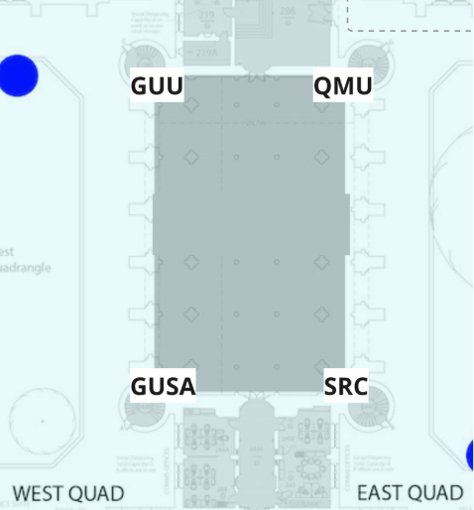

During the event:
- Everyone will participate in the event.
- 15 minutes before the event ends, the 2 support teams must quietly exit their seats and return to the exits they managed earlier.
- Their role will be to guide students out of the venue once the event finishes.

Take down:
- All helpers, including the support teams, should leave Bute Hall after the event ends.
- The 2 support teams should ensure a safe and orderly exit for everyone, holding open the doors as people leave.
- Once everyone has exited, the doors at the top and bottom of the stairs must be securely closed and signs taken down from the doors in the cloisters.

Queue management: Where there are queues building up, please make sure people are not blocking exits and entrances, and that they are not queueing in dangerous places (for example, across a road). Politely direct them to move from these spaces and try to maintain an orderly line.

